Community Neighbourhood Grant
Round 2 Capital

Guidance Notes

About Community Wealth Builder

We’re all about helping Doncaster’s communities grow stronger, more connected, and more resilient — by supporting the groups that make it all happen.
We’re here to help local groups do more and go further. Whether you’re a community organisation, a faith group, or a voluntary project, we offer free, tailored support to help you grow your impact.

From workshops and training, to advice about writing the best funding application to one-to-one support, we’re ready to help you build confidence, unlock new opportunities, and make a bigger difference in your area. Find loads of free resources and support on our website: For my organisation | Well Doncaster

So, if you’re doing work that supports your community, member of our team will are here to talk to you about your idea and help you make the changes you want to see.

Contact us at communitywealthbuilder@doncaster.gov.uk

About the Community Neighbourhood Grant, Capital Grant Round 2, 2025

If you’re part of a small group or organisation and you’ve got a plan to make your neighbourhood better — this grant could help you bring it to life.

Big changes often start small — with a good idea, a few passionate people, and a community that cares.
The Community Neighbourhood Grant is here to support those small, grassroots groups working hard to make life better in their local area. Whether it’s a new project to bring neighbours together, improve a shared space, or tackle something that matters to your community — this grant is designed to help you make it happen. It’s all about supporting the people who know their place best. The ones already making a difference, and the ones with ideas that could spark something new.

What’s it for?
This grant is for new projects only — fresh ideas that haven’t started yet. If you’ve got something ongoing, this particular fund isn’t the right fit. But if you’re dreaming up something new, we’d love to hear about it.

If you were successful in Round 1 for a revenue or capital grant you cannot apply for Round 2.

What can it cover?
Round 2 is for Capital Funding only is designed to help you invest in long-term improvements that support your work and help the community.

Eligible applicants must be from and delivering in Doncaster and include:
- Not-for-profit voluntary or community organisations
- Registered charities
- Faith-based organisations
- Not-for-profit companies, Community Interest Companies (CICs), or social enterprises

This grant is all about meeting real needs — the ones that come straight from the people who live here.
Through conversations with residents across Doncaster, we’ve heard what really matters to them. The priorities below reflect what’s important to them. So, when you’re putting together your application, take a moment to reflect:

- How does your idea speak to what people have said is most important?
- How could it help make life better in your neighbourhood?

This grant is here for helping communities shape their own future, so show us how your project connects with one or more of the priorities in your community.

Locality | Communities | Priorities
Central | Balby, Bessacarr, Cantley, Intake, Hexthorpe, Wheatley, Clay Lane, Lakeside, Belle Vue | - Resident involvement in creating community health and wellbeing activities  - Support/enable financial security  - Support/enable good health and wellbeing  - Creating cleaner, greener and safer communities for all to live, work and play
City Centre |  | - Support/enable financial security  - Support and enable good health and wellbeing  - Support/enable safe, affordable quality housing  - Creating cleaner, greener and safer city for all to live, work and play
East | Stainforth, Thorne, Moorends, Dunscroft, Hatfield Woodhouse and Lindholme | - Employment, skills and training  - Support parents, families, children and young people to achieve their full potential  - Creating cleaner, greener and safer communities for all to live, work and play  - Resident involvement in creating community health and wellbeing activities  - Access to Information, advice and guidance that supports and suits the needs to residents
North | Askern and Norton, Campsall, Bentley, Toll Bar, Arksey, Adwick, Carcroft, Highfields, Woodlands, Roman Ridge, Sprotbrough | - Connect people within their community to support social inclusion and access to opportunities locally.  - Support a local understanding of health and care and options for people to receive the right support at the right time with an additional focus on women's health advice and access.  - Ensure that residents understand the important of reporting information to services to help tackle off road bikes.  - Utilise familiar community buildings and open spaces to meet the needs of residents, families, children and young people through community based support, information and guidance.  - Create more local opportunities through social inclusion and family support to help people to be more economically active and supported into the world of work.
South | Edlington, Denaby, Rossington Mexborough, Conisbrough | - Support/enable safe, affordable quality housing  - Creating cleaner, greener and safer communities for all to live, work and play  - Utilise community buildings and green spaces to meet the needs of residents  - Resident involvement in creating community health and wellbeing activities  - Employment, skills and training

Capital Funding: for new projects that shape your space

If you’ve got a new idea that needs tools, materials, or improvements to get off the ground — this funding stream is here to help.

Capital funding is available for new projects only. It’s designed to support the practical things that help bring your vision to life — whether that’s equipment, repairs, or making spaces more welcoming and accessible.
Here are just a few examples of what this funding could cover:

- Building or improving spaces:
  - Renovating a community centre, health hub, or shared space.
  - Making buildings more accessible (e.g. ramps, lifts, disabled toilets).
  - Creating outdoor areas for wellbeing activities.
- Buying equipment:
  - Computers, tablets, or printers for service delivery.
  - Kitchen equipment for community cooking or food projects.
  - Furniture for drop-in spaces or meeting rooms.
- Infrastructure upgrades:
  - Broadband installation or digital connectivity.
  - Solar panels or energy-efficient improvements.
- Vehicles (if used for community benefit):
  - Minibuses for outreach or transport to activities

For example, a group might use funding to buy heat-mapping equipment — helping residents spot heat loss in their homes and improve their wellbeing.

If your project involves improving a green space, that’s great — as long as it benefits the wider community. Just make sure you’ve got written permission from the landowner if the space isn’t yours and include it with your application.

The grant cannot be used for things such as:
- Day-to-day running costs (e.g. staff wages, rent, utilities).
- One-off events or activities.
- Consumables (e.g. food, leaflets, PPE).
- Services that are already a statutory duty of the council.

What we’re especially keen to support:
We’re particularly interested in projects that:
- Protect and celebrate heritage buildings
- Improve the local environment
- Bring people together through arts and culture
- Help create healthy, warm homes across Doncaster

How much can you apply for?

You can apply for up to £5,000 to help bring your new idea to life. There’s no minimum amount — so whether your project is big or small, we’d love to hear about it.

Just a couple of things to keep in mind:
- Each organisation or group can apply once only- if you were successful in Round 1 for a revenue or capital grant in Round 1 you cannot apply for round 2.

Who can apply?

Eligible applicants must be from and delivering in Doncaster and include:
- Not-for-profit voluntary or community organisations
- Registered charities
- Faith-based organisations
- Not-for-profit companies, Community Interest Companies (CICs), or social enterprises

Monies from the fund will only be paid into a business bank and cannot be paid directly to individuals or un-constituted groups. Individuals or groups who are un-constituted and/or do not have a bank account are advised to contact your local Well Doncaster Officer, in the first instance, who will be able to support you to become a constituted group. You can find their details at the end of this guidance pack.

A few things to keep in mind before you apply

We want to make sure your application has the best chance of success — so here’s a quick guide to what isn’t covered by this grant.

It’s all about supporting new, community-led ideas that benefit the wider neighbourhood. That means there are a few things we can’t fund, even if they’re important in other ways. Take a look at the list below before you apply — and if you’re unsure about anything, just ask. We’re here to help.

- Activities promoting religious beliefs.
- Political activities.
- Goods or services that have already been purchased or ordered.
- Activities outside of the Borough of Doncaster.
- On-going organisational running costs.
- Trips and holidays.
- Costs that are already included within and funded by an existing grant or contract.
- School activities that are included within the curriculum (activities led by schools that engage the community will be eligible/considered).
- Endowments / loan repayments.
- Items that can only benefit an individual.
- Town and Parish councils
- Statutory Bodies

Monitoring, evaluation and celebrating success

Sharing your story — and showing your impact

We want to shine a light on the brilliant work happening across Doncaster’s communities — and that starts with you.

If your application is successful, we’ll ask you to share a few things with us to help show the difference your project is making. These are a required part of the funding, but don’t worry — your Well Doncaster Officer is here to support you every step of the way.

Here’s what we’ll need:
- A case study — this could be a short write-up, some photos, or even a quick video
- Evidence of spend — like receipts or invoices
- A completed Community Wealth Builder (CWB) monitoring form
- Your spend evidence within 30 days of receiving the payment
- Your case studies and CWB form within 3 months of payment

Need help pulling it together?
Your Well Doncaster Officer is here to guide you through it — just reach out.

Thinking of applying? Here’s when to get your form in

Round 2 Applications
- Open: Friday 24th October 2025
- Close: Friday 14th November 2025 at 12pm
- Decisions expected by: Friday 5th December 2025 (Subject to volume of applications)

Applications must be submitted through the MS Teams form, which will automatically close at the deadline. Please ensure you submit your application in good time to avoid missing out. To help you in completing your application, please see questions that will be on the MS Teams form below:

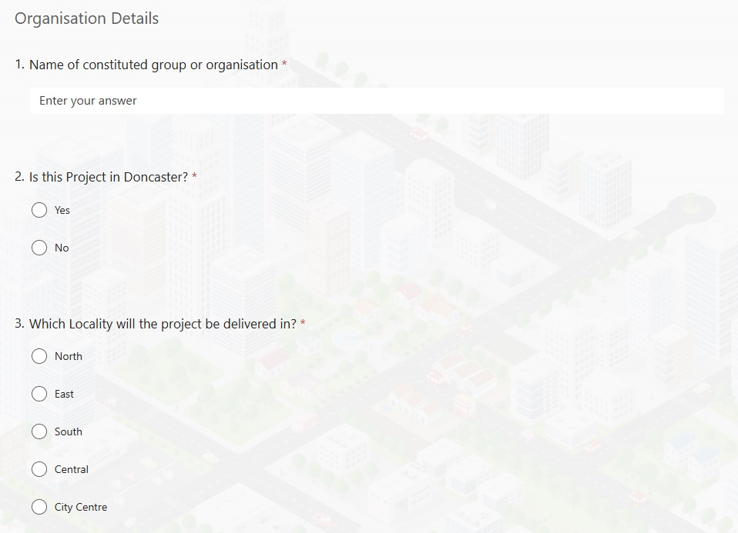

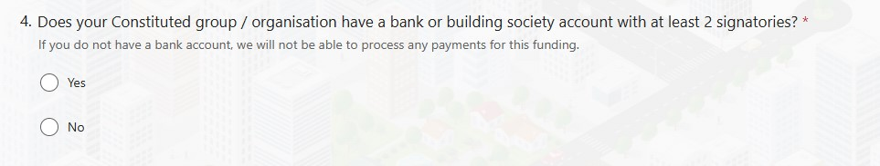
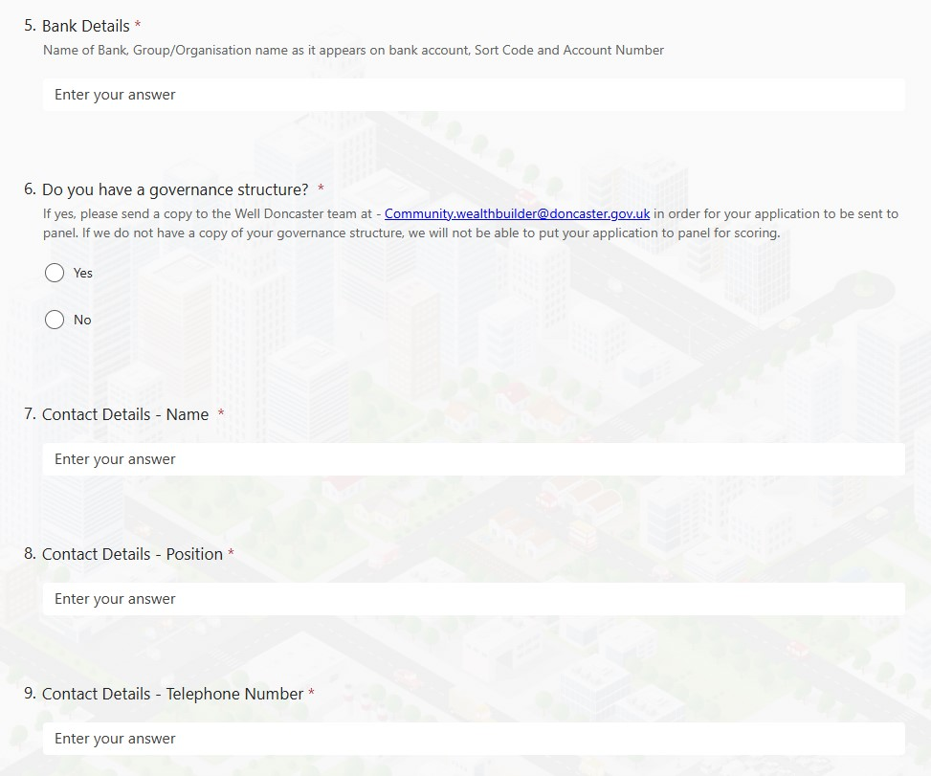

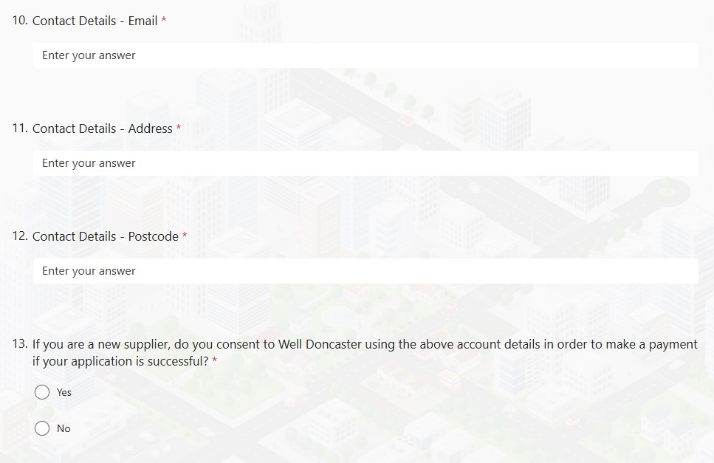
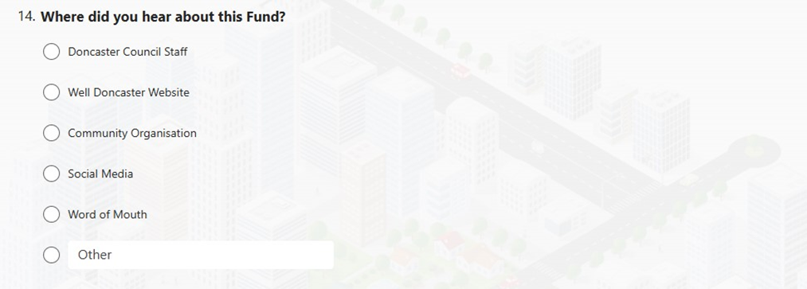

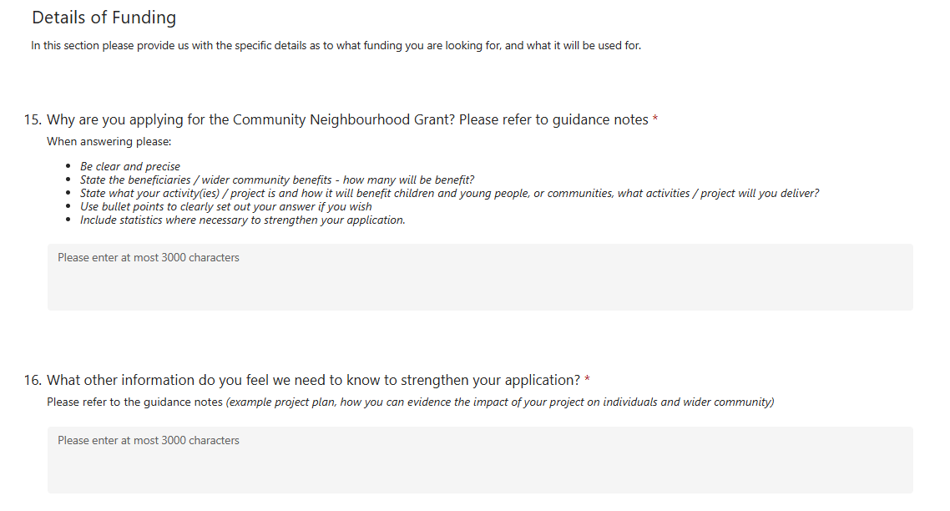
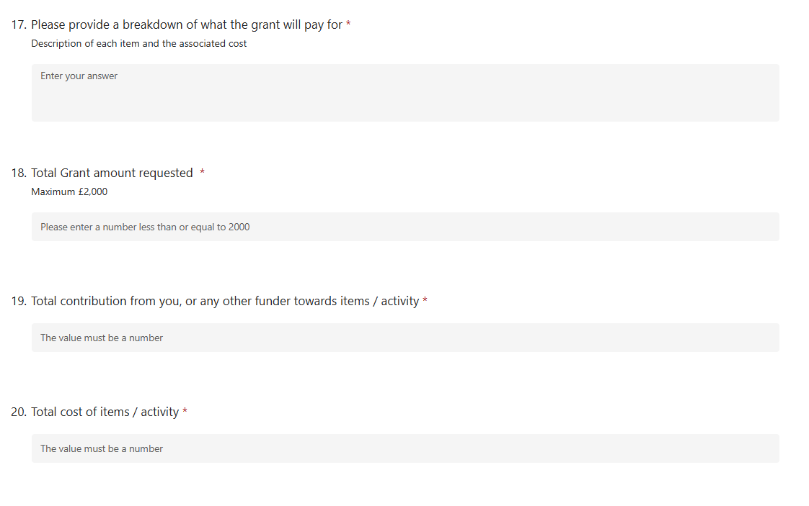
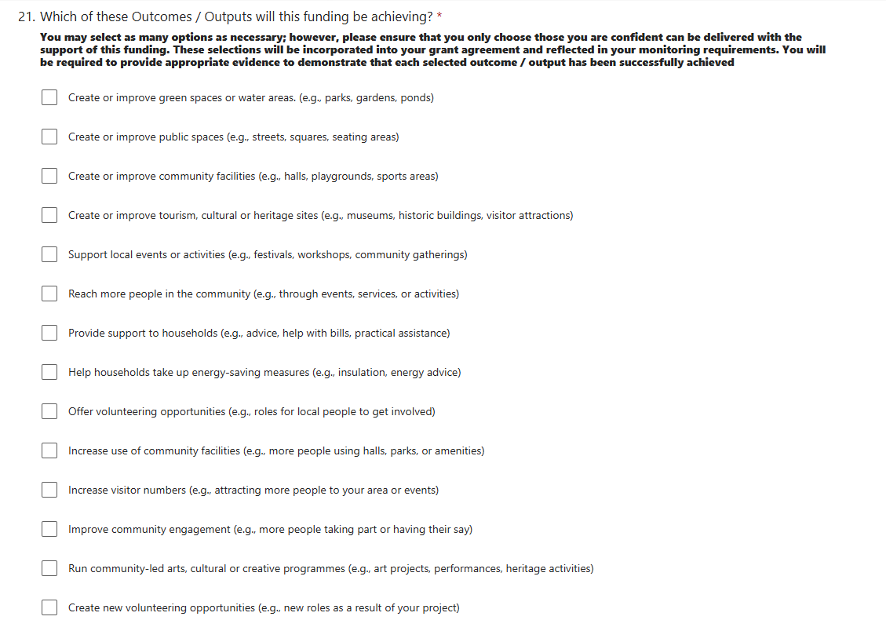

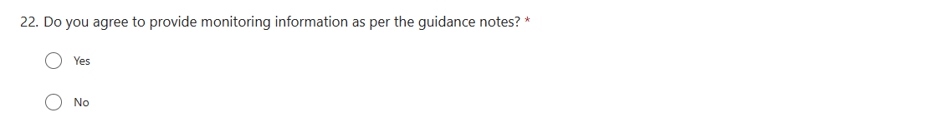

Important Notes
- Governance Documents: Applications must be accompanied by the relevant governance documents. We will not chase missing documents, and applications without them will not be considered.
- Monitoring Compliance: If your group has outstanding monitoring from previous grants, your new application will not be progressed until this is resolved.
- Safeguarding and DBS Checks: Successful applications will be subject to safeguarding and DBS checks. To avoid delays, please submit these documents alongside your governance documents if possible. We will reach out to obtain these if your application is successful and we do not yet have this information.

Please not that due to the time constraints in ensuring that you receive the funds prior to your project, the deadline will not be extended. Please submit all supporting documents to Community.WealthBuilder@doncaster.gov.uk by the deadlines.

What happens when you submit your application?

- You will receive an acknowledgement message after completing the MS Teams application which you can download to save a copy of.
- You may be contacted by the Community Wealth Builder Team to discuss your application in more detail or to ask for documentation.
- Applications will be assessed, and decisions given via email to the one included in your application.
- By accepting receipt of the fund, you must be willing to engage with the Community Wealth Builder Project and return any paperwork required.
- Successful applicants will be required to sign a grant agreement prior to release of the funds.
- Your local Well Doncaster Officer can provide support – keep in touch with them to let them know how you are doing.
- All monies must be spent by 13th February 2026
- All monitoring must also be returned by 13th March 2026

Unsuccessful applications

The decision is final and there is no right of appeal. However, unsuccessful applicants will be referred to their local Well Doncaster Officer for support, and they may be offered further support through Community Wealth Builder.

Apply / How to find out more:

These applications will be via a Microsoft teams form - https://forms.office.com/e/WTGcMcwkXv and all supporting documentation should be clearly marked Community Neighbourhood Grant and emailed to Community.WealthBuilder@doncaster.gov.uk or posted to Public Health, Well Doncaster, Floor 4, Civic Office, Waterdale, Doncaster, DN1 3BU

For more information and for support to develop your idea, please contact your Well Doncaster Officer or the Community Wealth Builder Team.

Area | Well Doncaster Officer
North | Daisy Joustra  Daisy.Joustra@doncaster.gov.uk  07483 941794  Kate Maguire  Katherine.Maguire@doncaster.gov.uk  07971 395978
East | Naomi Silvester  Naomi.Silvester@doncaster.gov.uk  01302737909  Charlie Bonner  Charlie.Bonner@doncaster.gov.uk  07483 179891
Central | Donna Jones  Donna.Louise-Jones@doncaster.gov.uk  07977837227  Josh Biggs O’May  Josh.Biggs-O’May@doncaster.gov.uk  07891785229  Megan Green  Megan.Green@doncaster.gov.uk  07890069700
South | Sarah McCoy  sarah.mccoy@doncaster.gov.uk  07977458387  Ayesha Dacunha  Ayesha.Da-Cunha@doncaster.gov.uk  07713455027
Community Wealth Builder | Emma Lovett-Jones  Community.wealthbuilder@doncaster.gov.uk  01302 737585

